**Project Charter: Skill Job Matching Tool**

**Project Overview**

The Skill Job Matching Tool is an automated AI application designed to empower professional career coaches in providing accurate and up-to-date career advice to clients. By combining client inputs and contextual information, the tool aims to enhance the career decision-making process by matching skills to high-demand job roles.

**Architecture**

**Project Justification**

The transition from education to professional employment often suffers due to uninformed career decisions. Professional career coaches face challenges in staying updated with evolving job roles and skills. The AI solution aims to address this gap by leveraging real-time data and context to guide coaches in offering relevant and beneficial advice.

**Project Objective**

The primary objective of this project is to develop an AI-driven tool that assists professional career coaches in providing effective career advice based on accurate skill-job matching. The tool will facilitate the alignment of students' skills and career aspirations with high-demand job roles.

**Project Scope**

The project will encompass the design, development, testing, and deployment of the Skill Job Matching Tool. It will include the integration of AI algorithms and data collection mechanisms

**Architecture**

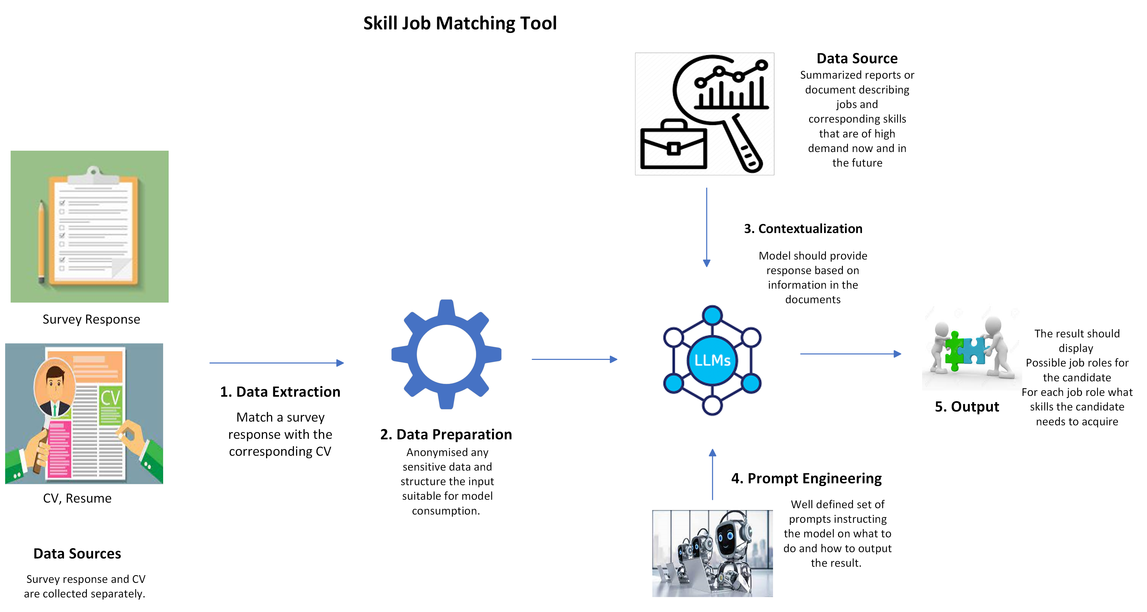

**Project Deliverables**

1. AI-driven Skill Job Matching Tool

2. Documentation and User Guides

3. Training Materials for Coaches

**Project Stakeholders**

- Project Sponsor: Graffiland

- End Users (Students, Graduates, professional career coaches)

**Project Team**

- Project Manager: Ivo Kubam

- Technical Lead: Victor Kubam

- AI Engineers and Developers

* Melvin Njauka
* Njinju Zilefac

**Project Timeline**

* Project Kickoff: 28/8/2023
* Design phase: 28/9 - 1/8 2023
* Development Phase: - 2/9 - 14/10 2023

- Testing and QA: 15/10 - 3/11 2023

- Deployment and Training: 4/11 - 11/11 2023

- Project Closure: 15/11/2023

**Budget and Resources**

* Funding: 500 Euro
* AI Development Resources
  + ChatGPT
* Data Collection Resources
  + Surveys, CVs, Resume, job reports
* Training and Support Resources

**Risks and Mitigation Strategies**

* Technical Challenges: Regular team meetings to address issues promptly.
* Data Privacy Concerns: Strict adherence to EU data protection regulations.
* Delayed Development: Regular progress assessments to prevent setbacks.

**Quality Control**

* Rigorous Testing: Thorough testing of the AI tool to ensure accuracy.
* User Feedback Loops: Continuous feedback from coaches and users for improvements.
* Peer Reviews: Regular reviews among team members to maintain quality.

**Change Management**

* Changes to Project Scope: Review by project sponsor and stakeholders.
* Communication: Clear communication channels for discussing and approving changes.

Project Approval